EXPERIMENT - 2
Set 2: Customer Feedback Analysis

Dataset: Customer Satisfaction
Customer ID | Age | Satisfaction Score
1 | 25 | 4
2 | 30 | 5
3 | 35 | 3
4 | 28 | 4
5 | 40 | 5

Question 1
Create a histogram to represent the distribution of customer ages. Label the axes and title the chart.

R Code
# Set 2 - Q1: Histogram of customer ages
age <- c(25, 30, 35, 28, 40)

hist(age,
main = "Distribution of Customer Ages",
xlab = "Age", ylab = "Frequency",
col = "lightblue", border = "black",
breaks = 5)

Output
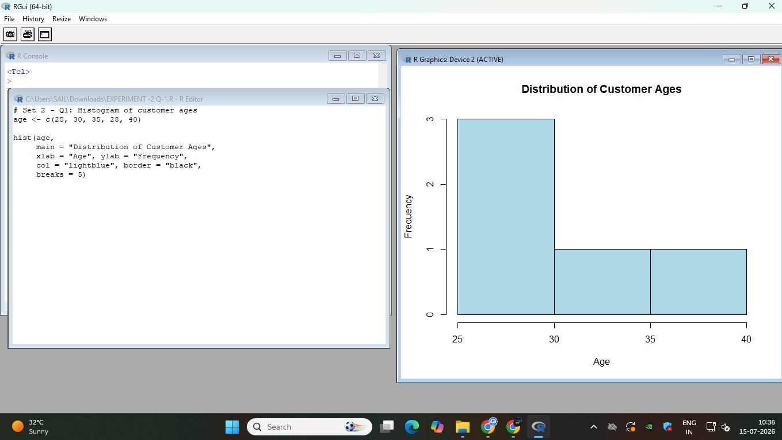

Question 2
Generate a pie chart to display the overall distribution of customer satisfaction scores. Include labels.

R Code
# Set 2 - Q2: Pie chart of satisfaction scores
satisfaction <- c(4, 5, 3, 4, 5)

score_table <- table(satisfaction)
pct <- round(100 * score_table / sum(score_table), 1)
labels <- paste(names(score_table), " (", pct, "%)", sep = "")

pie(score_table, labels = labels,
main = "Distribution of Customer Satisfaction Scores",
col = rainbow(length(score_table)))

Output
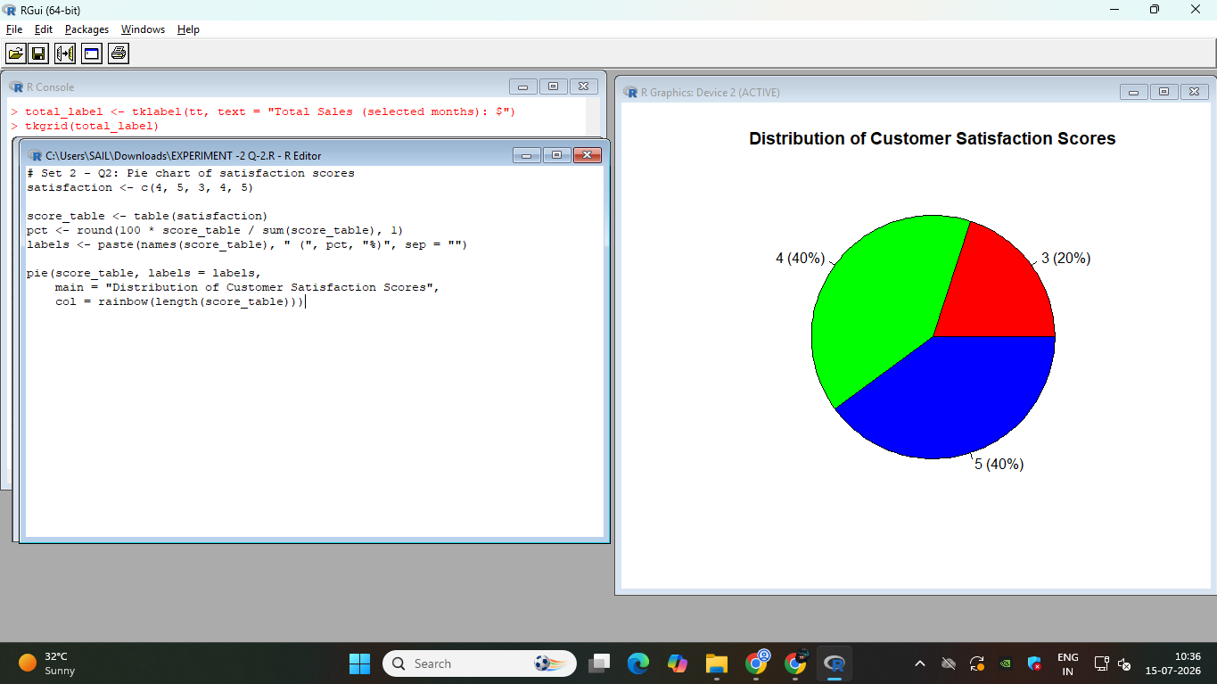

Question 3
Build a stacked bar chart to visualize the distribution of customer satisfaction scores by age group.

R Code
# Set 2 - Q3: Stacked bar chart - satisfaction by age group
customer_id <- 1:5
age <- c(25, 30, 35, 28, 40)
satisfaction <- c(4, 5, 3, 4, 5)

# Group ages into ranges
age_group <- cut(age, breaks = c(20, 30, 40, 50),
labels = c("21-30", "31-40", "41-50"))

# Build a table: rows = satisfaction score, columns = age group
tab <- table(satisfaction, age_group)

barplot(tab,
main = "Customer Satisfaction Scores by Age Group",
xlab = "Age Group", ylab = "Number of Customers",
col = rainbow(nrow(tab)),
legend.text = rownames(tab),
args.legend = list(title = "Satisfaction Score", x = "topright"))

Output
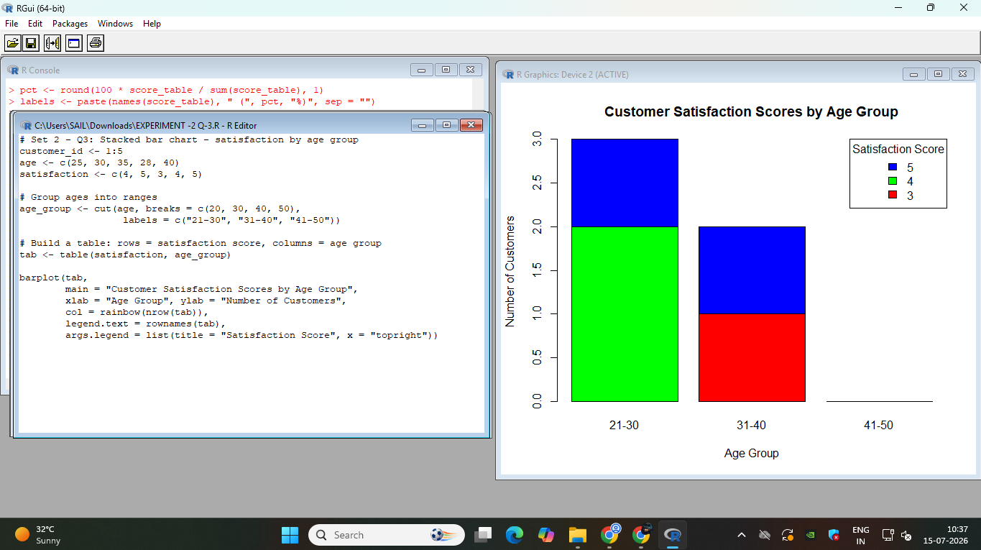

Question 4
Develop a word cloud from open-ended customer feedback to identify prevalent customer sentiments.

R Code
# Set 2 - Q4: Word cloud from open-ended feedback
# Needs: wordcloud, tm (text mining) packages - install once
install.packages("wordcloud")
install.packages("tm")

library(wordcloud)
library(tm)

feedback <- c(
"Great service and friendly staff",
"Delivery was late but product quality is good",
"Excellent support, very happy with the experience",
"Product broke after a week, poor quality",
"Fast delivery and great customer service"
)

corpus <- Corpus(VectorSource(feedback))
corpus <- tm_map(corpus, content_transformer(tolower))
corpus <- tm_map(corpus, removePunctuation)
corpus <- tm_map(corpus, removeWords, stopwords("english"))

wordcloud(corpus, min.freq = 1, scale = c(3, 0.5),
colors = brewer.pal(8, "Dark2"), random.order = FALSE)

Output
